Climate Hero Spotlight: Lineworkers

# Opening Activity: Power Runs Our Lives

**How would a power outage affect the different businesses and individuals on this busy street corner?**

|  |
| --- |
|  |

# The Big Question

How do lineworkers and other electric utility workers contribute to climate solutions?

# My Climate Goals

When you complete this lesson, you’ll be able to

1. Examine the role of lineworkers and how they contribute to climate resiliency and public safety
2. Discuss the relationship between lineworkers and the state’s climate goals
3. Identify the skills and training needed to become an electrical lineworker
4. Determine what aspects of a lineworker’s career align with your skills, interests, and desired work environment.

**Notes:**

|  |
| --- |
|  |

# 

Critical Response: Lineworkers in Emergencies

# Instructions

Your team represents a group of lineworkers responding to a climate emergency. Review the details of your assigned event to understand the challenges your team faces. Then, examine the schematic provided for your town’s power grid. Identify the areas affected by downed power lines and damaged infrastructure.

## How to Use Your Schematic Drawing

Each scenario is accompanied by an illustration of the town’s electrical grid, including the main power station, several electrical junctions, and the critical locations affected by the climate emergency.

To restore power to locations in town, you must restore power to any semi-operational or non-operational junctions connecting buildings to the power station. Electricity runs through power lines and junctions. Once you restore power to a junction point, it will distribute power through all connected lines until they reach a building or another junction point. The key below will help you.

**Red** power lines and buildings are currently without power.

**Red** junctions are non-operational and require significant maintenance to restore function.

**Gold** power lines and buildings with fluctuating, limited, or unstable power.

**Gold** junctions are semi-operational and require minor maintenance to restore function.

**Green** power lines and buildings are fully powered.

**Green** junctions are fully operational and can distribute power without any maintenance.

You can only reach junctions by traveling on roads shown as gray lines. Due to the emergency, some roads may be blocked by hazards, such as fallen trees or traffic disruptions. Your team will need to communicate with local authorities to coordinate clearing hazards so you can access junctions requiring maintenance.

Safety, weather, and hazards are all factors that should be considered when putting together the best way to restore power to the community.

# Response Plan Prompts

**Priorities: Which area(s) of the grid will you restore first and why?**

|  |
| --- |
|  |

**Safety concerns: What safety hazards does your team face?**

|  |
| --- |
|  |

**Steps to restore power: Outline the key tasks your team will complete to repair the grid and bring power back online for your town.**

|  |
| --- |
|  |

## Winter Storm Riley

**Scenario:** In March 2018, Winter Storm Riley—a powerful nor’easter—brought heavy snowfall, strong winds, and flooding to Massachusetts. The storm caused widespread power outages as trees and utility poles were brought down by the intense winds and heavy, wet snow. Lineworkers were called upon to restore power to more than 450,000 homes and businesses across the state.

Your team of lineworkers is at the forefront of this emergency response. Your role is crucial in restoring power to the affected areas, particularly the rural regions where access is challenging due to blocked roads and heavy snow accumulation. Hospitals and emergency services in several towns rely on your expertise to restore power quickly despite the hazardous conditions and dropping temperatures.

**Your mission:** As lineworkers, your task is to restore power to critical facilities and the community while ensuring the safety of your team and working efficiently under hazardous conditions.

**Key challenges:**

* Prioritize which areas to restore first.
* Safely access areas blocked by fallen trees and heavy snow.
* Follow safety protocols to prevent accidents.
* Coordinate with local authorities and keep the public informed about the restoration progress.

## 

## Tornado Outbreak

**Scenario:** In July 2021, a series of tornadoes struck Western Massachusetts, causing severe damage to homes, businesses, and power infrastructure. Trees and power lines were downed, leaving thousands without electricity. The tornadoes damaged several substations, adding further complexity to the restoration efforts. Your crucial role as lineworkers across the state, deployed to repair the extensive damage to above-ground and underground electrical systems, is invaluable.

Your team faces a critical mission—repairing the damage in one of the hardest-hit areas. Substations in the region have been severely damaged, and many residents are without power, including a nursing home that urgently needs electricity for medical equipment. However, strong thunderstorms are still forecast, posing additional risks.

**Your mission:** As lineworkers, your task is to restore power to critical facilities and the community while ensuring the safety of your team and working efficiently under hazardous conditions.

**Key challenges:**

* Prioritize which areas to restore first.
* Safely access areas blocked by fallen trees and hazards.
* Follow safety protocols to prevent accidents.
* Coordinate with local authorities and keep the public informed about the restoration progress.

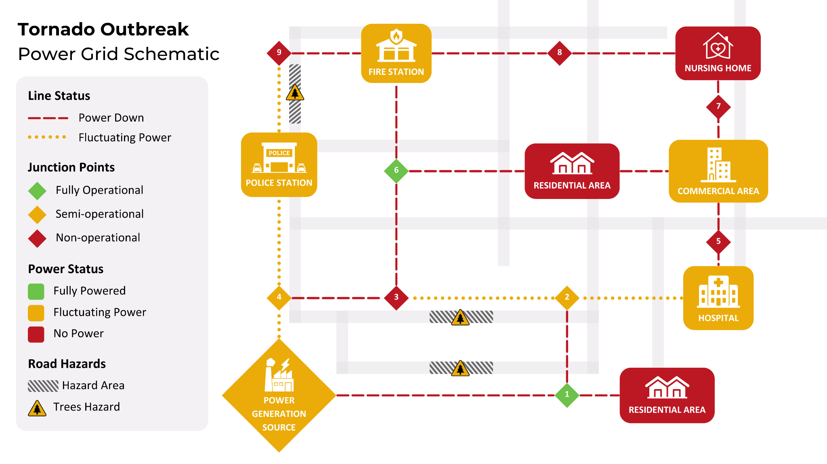

## 

## Extreme Heat Wave

**Scenario:** In August 2022, Massachusetts experienced an extended heat wave with record-breaking temperatures exceeding 100°F in some areas. The increased demand for air conditioning and cooling systems led to a surge in power consumption, overloading the electrical grid and causing rolling blackouts. Several power lines overheated, leading to widespread outages in both urban and rural areas. Your crucial role as lineworkers was dispatched to repair the affected lines and prevent further outages as demand increased, demonstrating the vital importance of your work.

Your team is deployed to an area where the power grid has been significantly affected. The heat is dangerous for the public and your crew, and there are concerns about heat-related illnesses. The potential impact of this heat wave on the community is significant. Critical infrastructure has lost power, including a local water treatment plant, and its operations must be restored to ensure the community has access to clean water.

**Your mission:** As lineworkers, your task is to restore power to critical facilities and the community while ensuring the safety of your team and working efficiently under hazardous conditions.

**Key challenges:**

* Prioritize which areas to restore first.
* Safely access areas blocked by fire hazards and traffic disruptions.
* Follow safety protocols to prevent accidents.
* Coordinate with local authorities and keep the public informed.

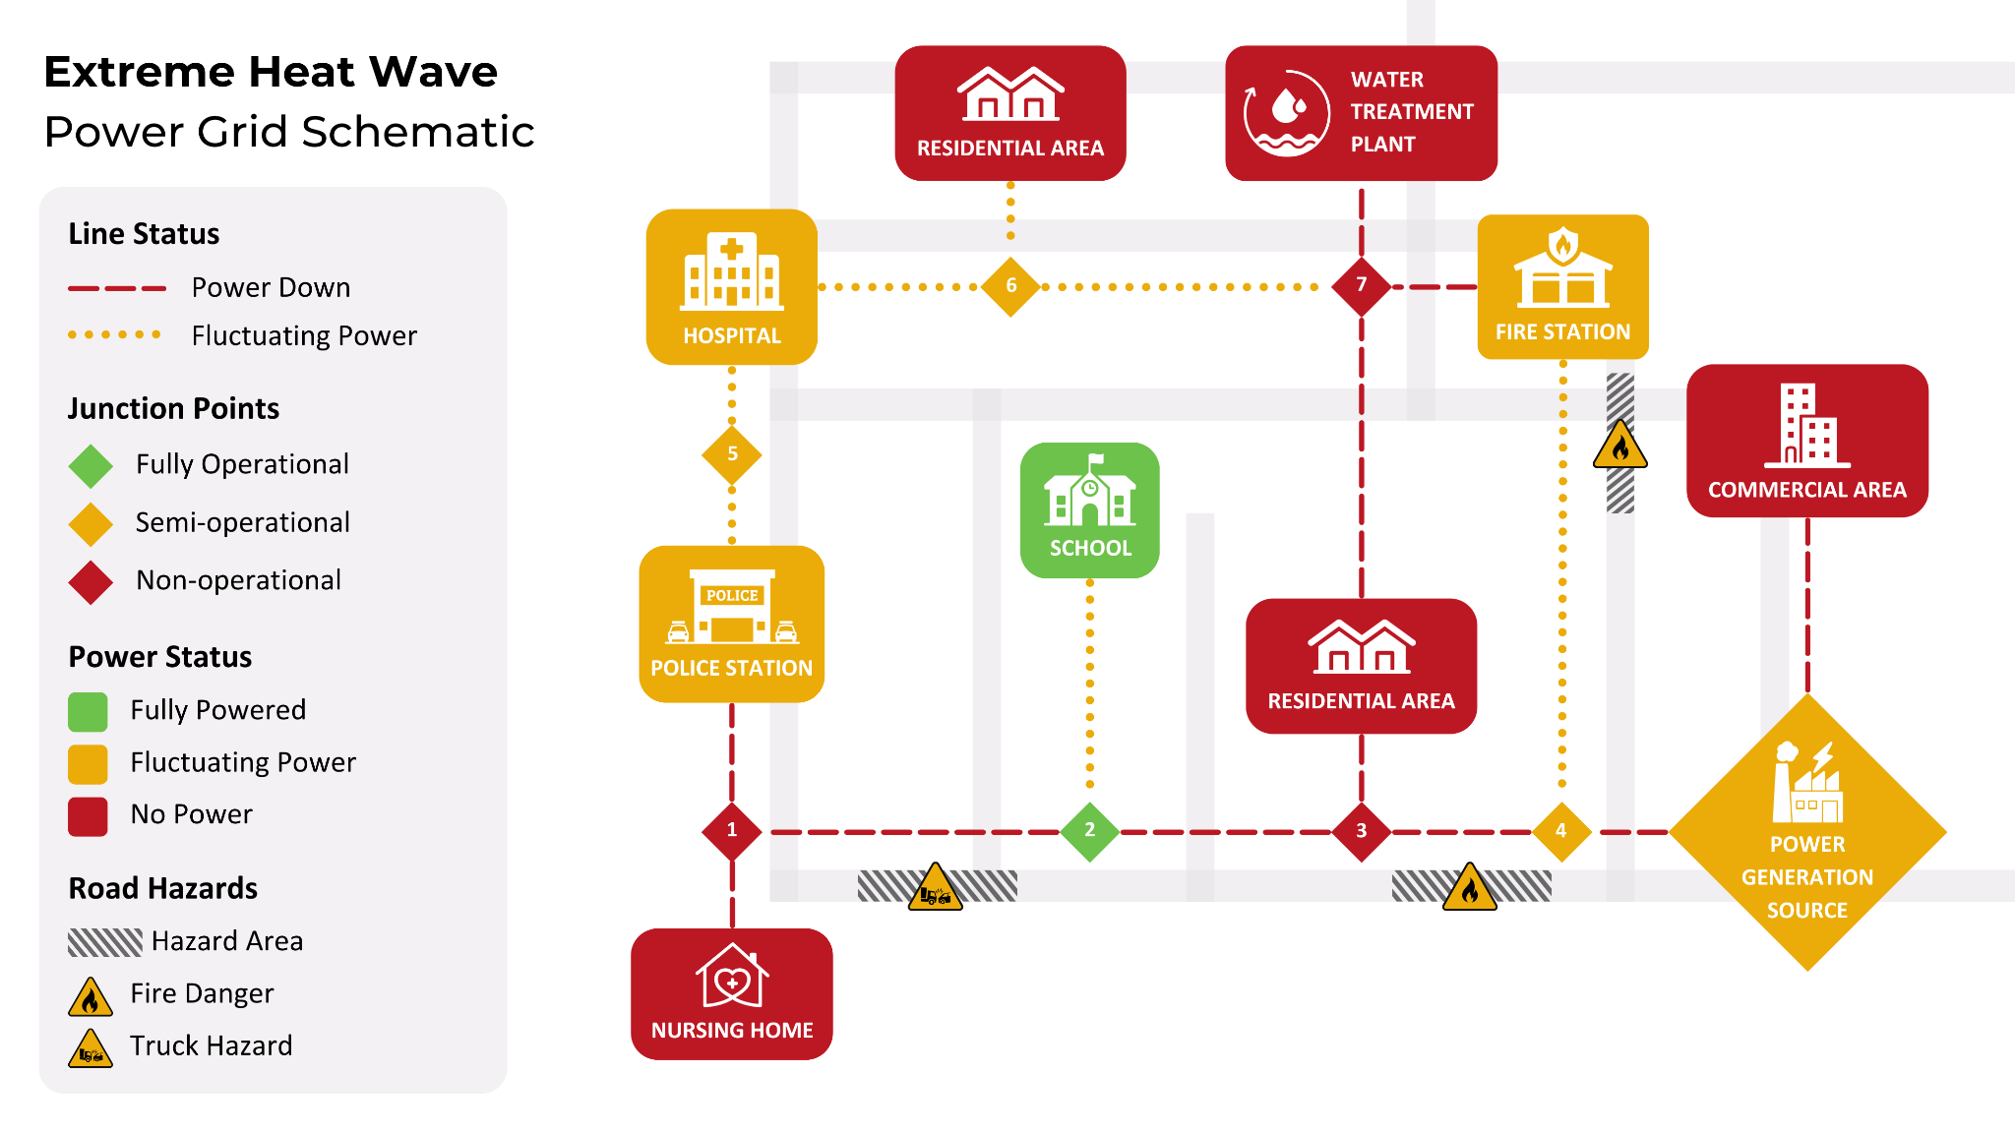

# Lesson Key Points

* Lineworkers are essential workers.
* Lineworkers contribute to climate resilience.
* The demand for lineworkers will continue to grow in Massachusetts.
* Linework requires a combination of physical and technical skills and training.

**Additional key points:**

|  |
| --- |
|  |

# Closing Activity

**Why are lineworkers critical to Massachusetts achieving its climate goals?**

|  |
| --- |
|  |

**How do lineworkers contribute to climate resiliency?**

|  |
| --- |
|  |

**What is one unique aspect of working as a lineworker?**

|  |
| --- |
|  |